CHENNAI MEDICAL COLLEGE HOSPITAL AND RESEARCH CENTRE, (SRM GROUP) IRUNGALUR, TRICHY – 621 105.
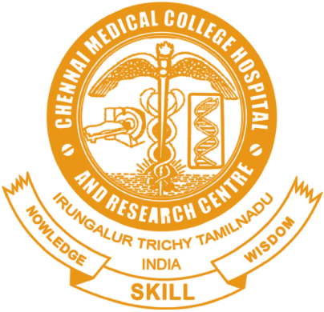
DEPARTMENT OF PHARMACOLOGY
PHARMACOVIGILANCE COMMITTEE MEMBERS LIST

S.No | Committee Members
 | Office Bearers
1. | Chairperson: Dean Dr.Sukumaran Annamalai
2. | Co-Ordinator : Dr.K.Vasanthira, HOD of Pharmacology
3. | Investigator : Dr.Thirumalaikolundusubramanian,Professor of Medicine
4. | Secretary : Dr.K.Kanagasanthosh , Assistant Professor of Pharmacology
5. | Notifier : Dr.T.Nivethitha, Assistant Professor of Pharmacology
 | Members List
6. | Dr.P.Anusuya - Medical Superintendent
7. | Dr.P.Gnanasekaran - Professor and HOD, General Medicine
8. | Dr.P.Karthick - Professor and HOD, General Surgery
9. | Dr.S.M.Kalamani - Professor and HOD , Obstetrics and Gynaecology
10. | Dr.D.Saminathan - Professor and HOD ,Paediatrics
11. | Dr. A.Navaneethan-Professor and HOD, Orthopedics
12. | Dr.N.Balasubramanian - Professor and HOD, Dermatology
13. | Dr.G.Prabaharan-Professor and HOD, Psychiatry
14. | Dr.T.K.Seethadevi - Professor and HOD ,Anaesthesiology
15. | Dr.S.Elango - Professor and HOD ,Community Medicine
16. | Medical officer i/c Casualty Dr.Prabhu
17. | Dr.K.Poonkothai - Resident Medical officer
18. | Mrs.Saraswathy - Nursing Superintendent
19. | Chief Pharmacist :-Mr.Neelakandan

HOD Signature

